Subtract the Product and Sum of Digits of an Integer
Platform: Leetcode
Language: C
Module 4, Question 3

Problem Link
https://leetcode.com/problems/subtract-the-product-and-sum-of-digits-of-an-integer/description/

Problem Statement
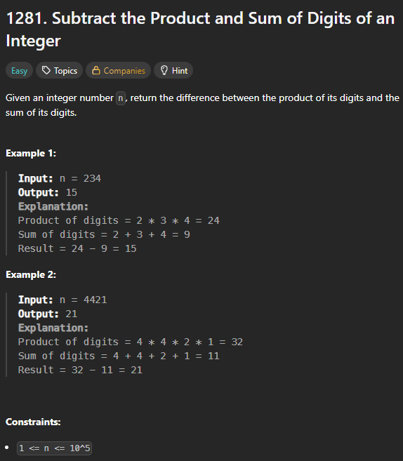

C Code
int subtractProductAndSum(int n) {
int product = 1, sum = 0;
while (n > 0) {
int d = n % 10;
product *= d;
sum += d;
n /= 10;
}
return product - sum;
}

Screenshot of Successful Submission



